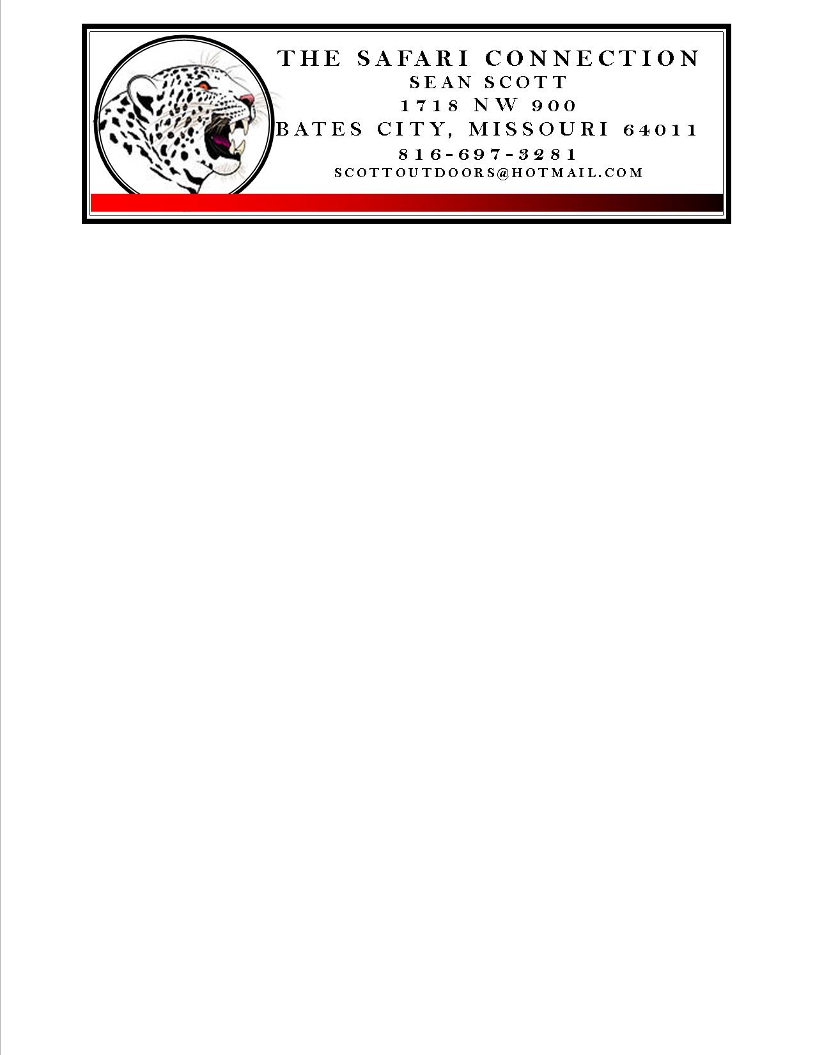

Namibian Firearms Import Information

Application for a Namibian Temporary Import Firearms Permit must be made by you arrival in Namibia. Unlike South Africa this is a simple and painless 5 minute process!! Below you will find basic info about the Namibian import process.

- There is no fee required for the permit or application.

- There is no limit on the number of firearms being imported but a 3 gun battery including a shotgun is the most anyone should need.

- Handguns, semi-automatic and automatics firearms are prohibited.

- A maximum of 80 rounds of ammo is allowed per firearm.

- Only ammo for the specific weapons being imported is allowed to be imported.

- On completion your permit application and inspection/acceptance by the on duty firearms officer you will be issued a permit which should accompany the firearms while in transport anywhere in Namibia.

- You can pre-fill the included application to speed your processing time on arrival it does not have to be done in the presence of the firearms officer.

- While it is not necessary for completing the import process we recommend you carry a copy of your US Customs 4475 while hunting and traveling in Namibia.

- Unfortunately the South African import process may be necessary if you are overnighting in South Africa on your way to Namibia or if the airlines you are flying do not have an inter-airline baggage transfer agreement. Contact your travel provider for this info!!

